**Part 1**

* **Step 1**

1. **Which command displays the statistics for all interfaces configured on a router?**

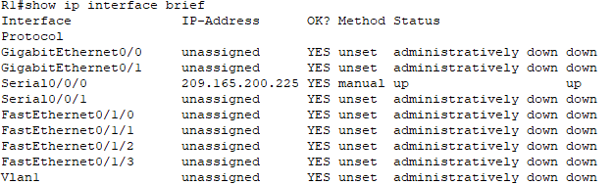

1. **Which command displays the information about the Serial 0/0/0 interface only?**

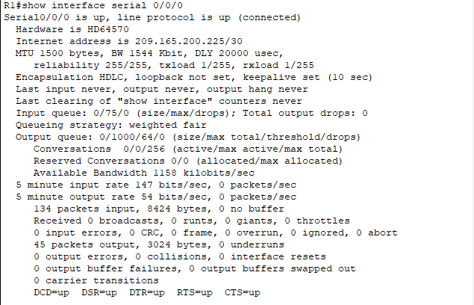

1. **Enter the command to display the statistics for the Serial 0/0/0 interface on R1 and answer the following questions:**

**1) What is the IP address configured on R1?**

209.165.200.225/30

**2) What is the bandwidth on the Serial 0/0/0 interface?**

1544 Kbits

1. **Enter the command to display the statistics for the GigabitEthernet 0/0 interface and answer the following questions:**

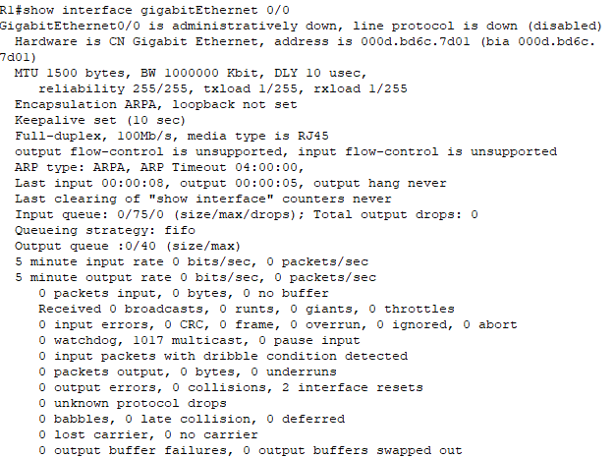

1. **What is the IP address on R1?**

There is no IP address configured on the GigabitEthernet 0/0 interface.

1. **What is the MAC address of the GigabitEthernet 0/0 interface?**

000d.bd6c.7d01

1. **What is the bandwidth (BW) of the GigabitEthernet 0/0 interface?**

1000000 Kbits

* **Step 2**

1. **Which command displays a brief summary of the current interfaces, interface status, and the IP addresses assigned to them?**

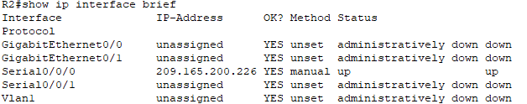

**b. Enter the command on each router and answer the following questions:**

**1) How many serial interfaces are there on R1 and R2?**

Each router has 2 serial interfaces

**2) How many Ethernet interfaces are there on R1 and R2?**

R1 has 6 Ethernet interfaces and R2 has 2 Ethernet interfaces.

**3) Are all the Ethernet interfaces on R1 the same? If no, explain the difference(s).**

No, they are not. There are two Gigabit Ethernet interfaces and 4 Fast Ethernet interfaces. Gigabit Ethernet interfaces support speeds of up to 1,000,000,000 bits per second and Fast Ethernet interfaces support speeds of up to 100,000,000 bits per second.

* **Step 3**

1. **What command displays the contents of the routing table?**

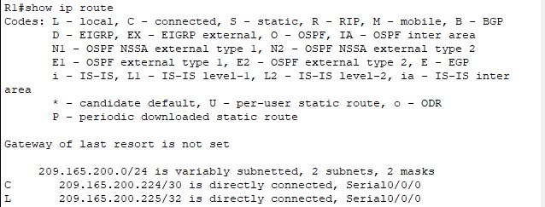

1. **Enter the command on R1 and answer the following questions:**

**1) How many connected routes are there (uses the C code)?**

1

**2) Which route is listed?**

209.165.200.224/30

**3) How does a router handle a packet destined for a network that is not listed in the routing table?**

A router will only send packets to a network listed in the routing table. If a network is not listed, the packet will be dropped.

**Part 2**

* **Step 3**

**Save the configuration files on both routers to NVRAM. What command did you use?**copy running-config startup-config

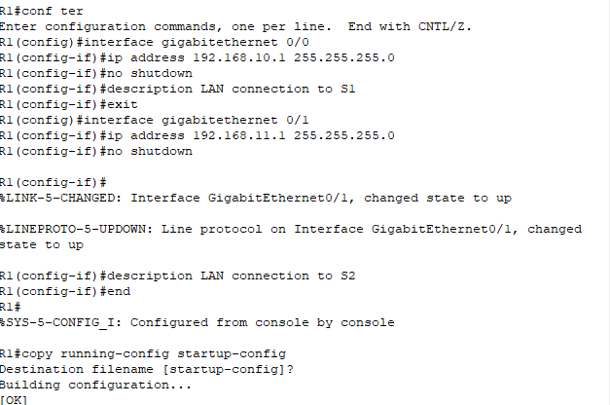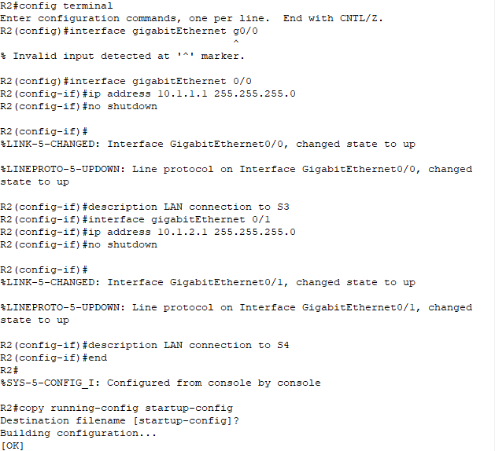

**Part 3**

* **Step 1**

1. **Use the show ip interface brief command on both R1 and R2 to quickly verify that the interfaces are configured with the correct IP address and are active.**

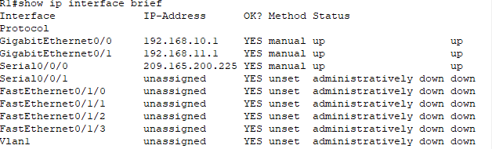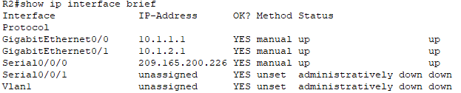

**How many interfaces on R1 and R2 are configured with IP addresses and in the “up” and “up” state?**

3 on each router

**What part of the interface configuration is NOT displayed in the command output?**

The subnet mask

**What commands can you use to verify this part of the configuration?**

show run, show interfaces, show ip protocols

1. **Use the show ip route command on both R1 and R2 to view the current routing tables and answer the following questions:**

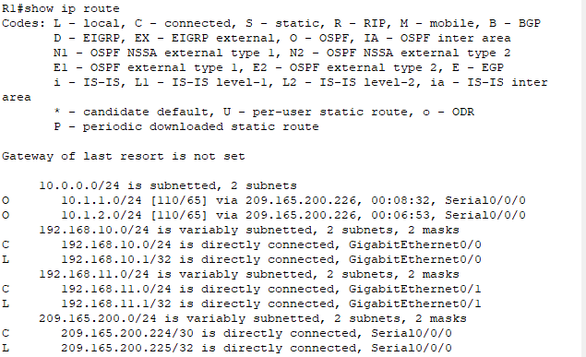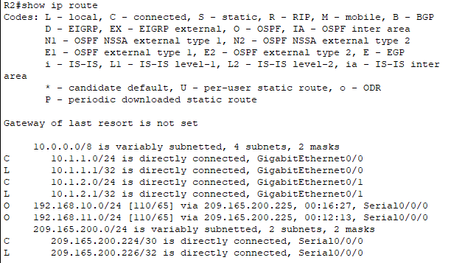

**1) How many connected routes (uses the C code) do you see on each router?** 3

**2) How many OSPF routes (uses the O code) do you see on each router?** Both R1 and R2 show 2 OSPF routes.

**3) If the router knows all the routes in the network, then the number of connected routes and dynamically learned routes (OSPF) should equal the total number of LANs and WANs. How many LANs and WANs are in the topology?** 5

**4) Does this number match the number of C and O routes shown in the routing table?** Yes